Hello World Application on Openshift (RedHat)

1. Made a Hello world application in Python language and stored it in the below GitHub repository.

<https://github.com/lavleenbhat/cloudarchitecture2017.git>

**Application:** [**cloudarchitecture2017**](https://github.com/lavleenbhat/cloudarchitecture2017)/**helloworld.py**

1. Created an account on OpenShift provided by Redhat.
2. Created the application on Python using the Web Console.

Project: Cloud Architecture

Deployment: helloworld

Application after deployment:

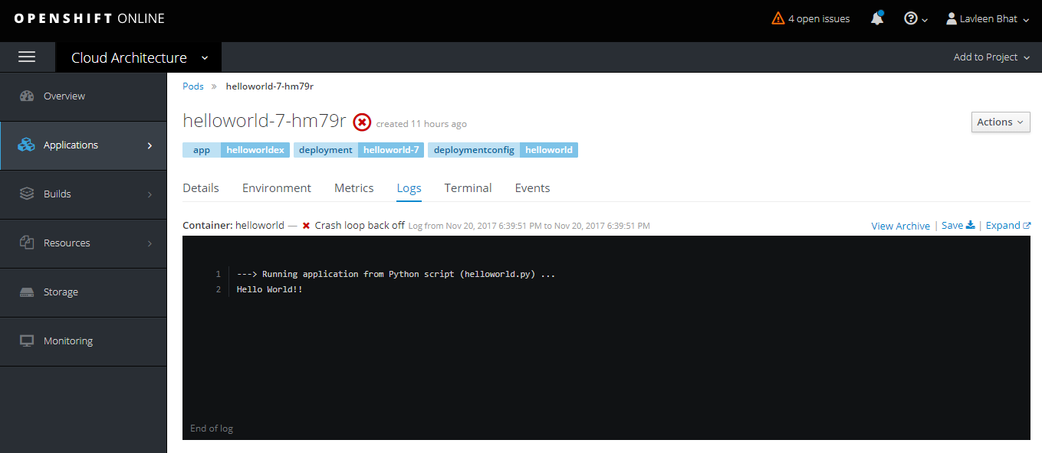

The application was deployed successfully but the only problem faced is described below. The application code was referenced from the GitHub repository given above.

Challenges:

* The application was running on a loop and it kept on crashing by back off.
* Lack of debugging. Have to learn how to debug on OpenShift.

Error description:

